“How to Train Your Dragon”
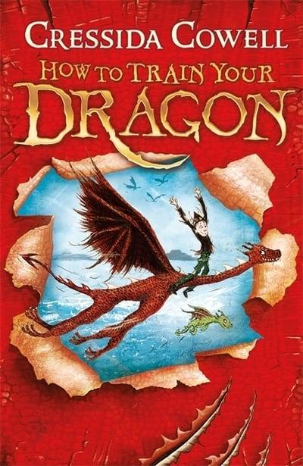
Home Learning Log

Complete one activity on Thursday and one activity on Friday.
Independent Work
Create your own Dragon Top Trump cards. Use “A note from Hiccup” to give you ideas for the description.

Description:
Description:
Description:
Description:

Independent Work
Write your own set of instructions on how to trap a dragon below. Remember – keep in chronological order, use imperative verbs and powerful vocabulary.

Independent Work
Write a character profile for one of the characters in the book. It could be a human or Viking.
What are their personalities like? What are their strengths / weaknesses? How do they change throughout the course of the story?

Independent Work
Use the map outline to design a location for a new part of the story. Write a description of this location using a range of vocabulary.

Independent Work
Look back at the new map you created. Write a short story which is based there.
Independent Work
Use the post it notes to write down questions you’d like to ask Hiccup.
Question 1
Independent Work
Question 1
Question 1
Question 1
Question 1
Question 1
Are heroes born or made?
Use the table below to give reasons for each side of this question.
Born | Made

Independent Work
Design your own dragon. Take inspiration from the images below by the artist ‘Draconika’. Select a range of high quality words to annotate around the outside.

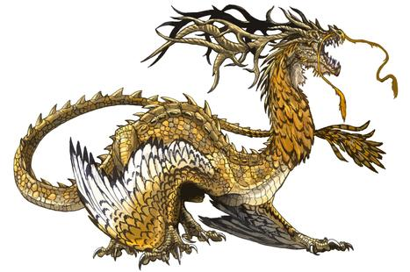
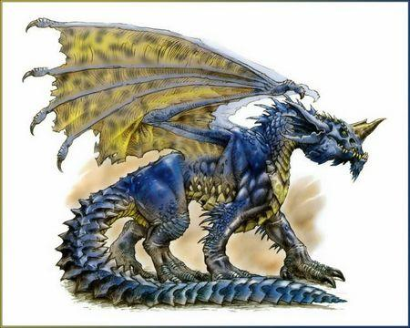

Independent Work
What clues are there that the book is set in a different time and place?

What are the themes in the book? Find evidence for them.

The writer uses many different text types within the book. Why? What is the effect?

Independent Work
Debate –
Could dragons of ever existed?
Use the table below to give reasons for and against the existence of dragons.
YES | NO

Independent Work
Produce a short, fictional report on dragons. Use some of the information you’ve acquired from reading the story.
Remember all the features of report writing.

Dragons
_
_
_

