History and Geography Curriculum
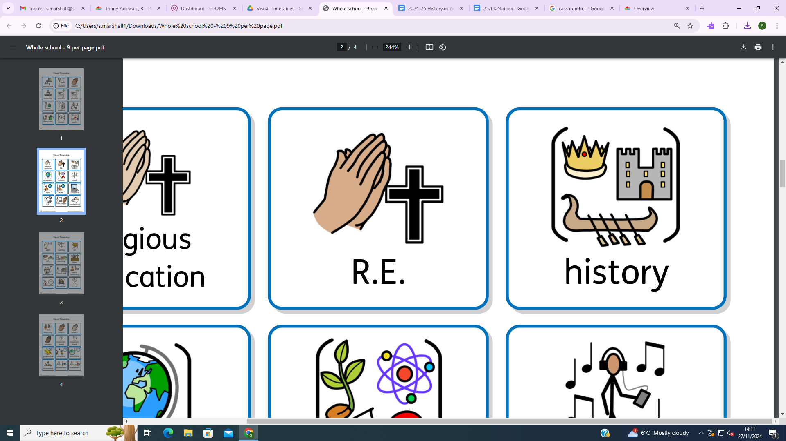
History is all around us. The study of history ignites children’s curiosity about the past in Britain and the wider world. Through finding out about how and why the world, our country, culture and local community have developed over time, children understand how the past influences the present. We aim to offer a high-quality history education to help pupils gain a coherent knowledge and understanding of Britain’s past and that of the wider world. To ensure that this happens, the children will revisit key threads of knowledge through the different periods of history they cover. History helps pupils to understand the complexity of people’s lives, the process of change, the diversity of societies and relationships between different groups. It also helps children gain a sense of their own identity within a social, political, cultural and economic background. We want to inspire pupils’ curiosity to know more about the past and encourage them to question and investigate. We want to develop a strong understanding within our children of where they fit in within the historical timeline and our goal is to provide children with the opportunities to look back through their education and use prior knowledge to make links. The children will learn about chronology, significant historical events and people, considering connections, contrasts and trends over time. Children should be equipped to ask perceptive questions, think critically, weigh evidence, sift arguments, and develop perspective and judgement.

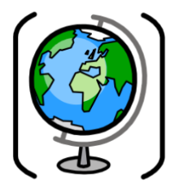
Geography is all about understanding the world we live in. It helps to provoke and provide answers to questions about the natural and human aspects of the world. At Sacred Heart, children are encouraged to develop a greater understanding and knowledge of the world, as well as their local environment. Our aims are to fulfil the requirements of the National Curriculum for Geography; providing a broad, balanced and differentiated curriculum; ensuring the progressive development of geographical concepts, knowledge and skills; and for the children to develop a love for geography. Furthermore, we aim to inspire in pupils a curiosity and fascination about the world and its people, as our pupils are from a diverse demographic and we want our differences to be celebrated. As children progress, their growing interest and understanding of diverse places, people, resources and natural and human environments, together with a deep understanding of the Earth’s key physical and human processes, will develop and remain with them for the rest of their lives.

Year group | Autumn | Spring |  | Summer
Year 1 | The World and My School  GEOGRAPHY  Where in the world do I live?  Toys and technology  (Changes within living memory)  HISTORY  How have children’s toys changed since our older relatives were little? | Kings, Queens and Castles  (Signiﬁcant individuals and local places)  HISTORY  Where did Kings and Queens live through time?  GEOGRAPHY FIELDWORK  Our local park  What is at our local park? How do people get there?  Pioneering women  HISTORY  Which pioneering women have shaped healthcare and medical science? |  | GEOGRAPHY FIELDWORK  Our school environment  Do our school grounds support plant life?  Local History – West Midlands  HISTORY
Year 1 | Key History objectives (Pupils must know and remember these facts / Improve, hone & apply these skills)  - Chronology- Label timelines with words such as: past, present, older and newer. Place events and artefacts on a timeline  - Evidence and interpretation- Recount changes that have occurred in my own life. With support, use and handle evidence to ask questions about the past.  - Cause and Consequence- Know and discuss causes that lead to toys and technology changing.  Begin to know and explain why monarchs built castles and consequences.  - Change and Continuity- Know and say which toys and technology has changed.  Describe changes in historical events.  - Similarities and Differences- Use pictures to compare toys, technology and castles from past to present.  - Historical Significance- Know and begin to talk about significant toys and technology from the past and key events of significant kings/queens or castles. |  | Key Geography objectives (Pupils must know and remember these facts / Improve, hone & apply these skills)  - Place- Understand that places have meaning.  - Space- Understand the world has seven continents and five oceans.  - Scale- Understand how my local area fits within the United Kingdom.  - Physical and Human process- Identify seasonal and weather patterns in the UK.

Year group | Autumn | Spring |  | Summer
Year 2 | Technology over time  HISTORY  How has technology changed over the last 60 years?  GEOGRAPHY FIELDWORK  Local area  Exploring our local area guidance (mainly  consolidation) | Local geography and Mexico  GEOGRAPHY  What are the similarities and differences between Aston and Tulum, Mexico?  Explorers  HISTORY  Where have humans explored? |  | Local History- West Midlands  HISTORY  How did the Burton-Swadlincote-Ashby Light Railway change the way people travelled and lived in the past?  The Great Fire of London  HISTORY  How did the Great Fire change London?  Investigating weather and climate  GEOGRAPHY FIELDWORK  How can we record and measure weather phenomena?
Year 2 | Key History objectives (Pupils must know and remember these facts / Improve, hone & apply these skills)  - Chronology- Place events, artefacts and figures on a timeline.  - Evidence and interpretation- With support, use and handle evidence to ask questions about the past.  - Cause and Consequence- Know and discuss the causes of exploration and what we have learnt from this. To know and explain the causes of the Great Fire of London and what the consequences were.  - Change and Continuity- Can describe changes over time and they have impacted on the 21st century.  - Similarities and Differences- Use pictures, stories, artefacts and diary entries to compare similarities and differences. Know and explain different ways the past has been represented.  - Historical Significance- Name significant people from the past and explain why they are important. |  | Key Geography objectives (Pupils must know and remember these facts / Improve, hone & apply these skills)  - Place- Understand and explain that places have meaning.  - Space- Understand the world has seven continents and five oceans and that the UK is split into countries.  Identify some key human and physical features of my local area.  Use simple compass directions and directional language when handling a map.  - Scale- Understand the countries that make the UK.  - Physical and Human process- Understand the impact the poles and equator has on the climate on Earth.  - Cultural Awareness and Diversity-Know the similarities and differences between my country and other countries.

Year group | Autumn | Spring |  | Summer
Year 3 | Stone Age to Iron Age  HISTORY  How did daily life change from the Stone Age to the Iron Age? | GEOGRAPHY FIELDWORK  Land use, economic activity and travel  What facilities are in my local area and how to people travel there?  Ancient Egypt  HISTORY  What were the greatest achievements of Ancient Egypt? |  | The United Kingdom  GEOGRAPHY  What are the key geographical features of the UK, and my region?  GEOGRAPHY FIELDWORK  Bee conservation  How can we make our school environment more bee friendly?
 | Key History objectives (Pupils must know and remember these facts / Improve, hone & apply these skills)  - Chronology- Place ages, events, figures and artefacts on a timeline using dates and understand meaning of their names.  With support, use BCE and CE.  - Evidence and interpretation- Explain how we find prehistoric evidence. Use more than one source of evidence in order to gain a more accurate understanding of history and come to conclusions based on what has been seen.  - Cause and Consequence- Suggest causes and consequences of the main events within prehistory and Ancient Egypt.  - Change and Continuity- With support, begin to explain the concept of change over a long period of history.  - Similarities and Differences- Describe similarities and differences between periods of time (Stone, Bronze and Iron age. Old and new Egypt).  - Historical Significance- Suggest suitable sources of evidence for historical enquiries. Discuss the importance of people and events in time and the significant impact they had on Britain. |  | Key Geography objectives (Pupils must know and remember these facts / Improve, hone & apply these skills)  - Place- Understand and explain that places have meaning and understand that people can choose to use land differently.  - Space- Understand that the UK is split into regions, counties and countries.  Identify some key human and physical features of my region and the UK.  Use compass points, four figure grid references, symbols and keys.  Scale- Understand the countries that make the UK and how my region is an area within England.  - Physical and Human process- Identify mountains, hills and rivers on maps.  Understand human processes that take place in the UK, including settlements.  - Cultural Awareness and Diversity- Understand that England is made up of region and that people living in these regions may have different sense of identity.

Year group | Autumn | Spring |  | Summer
Year 4 | My region and Italy  GEOGRAPHY  What are the similarities and differences between my region and Campania, Italy?  (Deliver L1 and 9 of Y3 unit first as an introduction) | Ancient Greece  HISTORY  What were the greatest achievements of Ancient Greece?  GEOGRAPHY FIELDWORK -  Locality study: Birmingham  How can I use mapping skills to learn about Birmingham? |  | Roman Empire  HISTORY  How did the Roman Empire impact Britain?  GEOGRAPHY FIELDWORK  Investigating weather and climate  How can we record and measure weather phenomena?
Year 4 | Key History objectives (Pupils must know and remember these facts / Improve, hone & apply these skills)  - Chronology- I can place events, artefacts and historical figures on a timeline, using dates and time (BCE/CE) and accurately describe events and people.  - Evidence and interpretation- Begin to use sources of evidence to deduce information. Suggest more than one suitable source for historical enquiry, while beginning to discuss the reliability of sources.  - Cause and Consequence- Evaluate causes and consequences of some of the main events in Britain when it was invaded.  - Change and Continuity- Explain the concept of rapid change and continued change over time in Britain and represent this with evidence.  - Similarities and Differences- Describe the social, ethnic, cultural and religious diversity of the past. Explain different accounts of events and explain why the accounts may differ.  - Historical Significance- Discuss the importance of people and events in time and the impact on our lives today. Describe social, cultural significance of a past society. |  | Key Geography objectives (Pupils must know and remember these facts / Improve, hone & apply these skills)  - Place- Understand and explain that places have meaning, make some suggestions or examples and know that people can use land in different ways.  - Space- Identify the continents in the world, use maps to identify some European countries and their capital cities.  Identify some key physical features and settlements.  Use compass points, four figure grid references, symbols and keys.  Compare and contracts physical and human features of various regions.  Scale- Understand there are town and cities in my region and in Italy. Understand both England and Italy are located in Europe.  - Physical and Human process- Understand how tectonic plates move and how earthquakes and volcanoes happen.  - Understand that physical and human processes force changes on Earth.  - Cultural Awareness and Diversity- Understand similarities and differences between a local region and Campania, and give some examples.  Know that cultural identity may vary from region to region.

Year group | Autumn | Spring |  | Summer
Year 5 | Anglo Saxons and Vikings  HISTORY  How did England change during the settlement of the Anglo-Saxons and Vikings?  GEOGRAPHY FIELDWORK-  Rivers  What are the features of my local river? | GEOGRAPHY FIELDWORK –  Biomes and Ecosystems  What trees, plants and animals are in our local ecosystems? |  | My region and the Western USA  GEOGRAPHY  What are the similarities and differences between my region and the Western USA?  The Ancient Maya  HISTORY  What similarities and differences are there between the Maya civilisation and England from the 8th to the 10th century?
 | Key History objectives (Pupils must know and remember these facts / Improve, hone & apply these skills)  - Chronology- Use dates, artefacts, figures and terms accurately to describe events.  Describe the main changes in a period of time- social, religious, political, technological and cultural.  - Evidence and interpretation- Suggest suitable sources and discuss their reliability. Analyse a wide range of evidence to justify claims about the past.  - Cause and Consequence- Suggest causes and consequences of some of the main events in history.  - Change and Continuity- Identify changes over a time. Analyse why certain changes happened, using appropriate historical vocabulary.  - Similarities and Differences- Compare changes in period of history with today describing social, cultural and religious diversity.  - Historical Significance- Discuss the importance of people and events in time and the significant impact they had on society, beginning to use some evidence to prove discussions. |  | Key Geography objectives (Pupils must know and remember these facts / Improve, hone & apply these skills)  - Place- Understand that people in a particular region can have a strong identity. Know that people can choose to use land in different ways and that this can depend on the land's physical geography and climate, giving examples.  - Space- Identify the location of my region in England and the key human and physical features of my region as well as some of the countries of North America and their capital cities.  Know some key settlements in Western USA.  Give examples of how the landscape in the Western USA varies massively, e.g. climate belts and biomes.  Understand the position and significance of latitude, longitude, equator, hemispheres, the tropics, circles and time zones.  - Scale- Understand how my region is an area within England and that there are towns and cities within my region.  Understand that England is a country within the continent of Europe.  Know that the USA is a country within the continent of North America.  Explain that the West is a region within the USA. I understand that there are states, cities and towns within the West region of the USA.  Make comparisons between my country and the US in terms of the size of the land and the population.  - Physical and Human process- Understand that physical and human processes force changes on Earth e.g. water cycle.  Explain rivers and mountains, and how they are formed.  - Cultural Awareness and Diversity- similarities and differences between my country and other countries and give some egs

Year group | Autumn | Spring | Summer
Year 6 | Crime and punishment  HISTORY  How has crime and punishment changed over time in Britain?  GEOGRAPHY FIELDWORK  Sustainability  How can our school reduce plastic waste? | World War 2  HISTORY  Why was the Battle of Britain a signiﬁcant turning point for the United Kingdom in World War Two? | UK Depth Study  GEOGRAPHY  What is the economic activity of the UK and how sustainable is it?  Economic activity of the UK -  GEOGRAPHY  What is the economic activity of the UK, and how sustainable is it?

 | Key History objectives (Pupils must know and remember these facts / Improve, hone & apply these skills)  - Chronology- Use dates, artefacts, figures and terms accurately to describe events and people.  - Evidence and interpretation- Use sources to form conclusions and testable hypothesis about the past. Explain that no single source can provide a full answer.  - Cause and Consequence- Describe the causes and consequences of key events in history.  - Change and Continuity- Identify periods of rapid change in history compared with time of little change.  - Similarities and Differences- Compare and contrast key people, events, cultures and artefacts in history.  - Historical Significance- describe the characteristic features of the past, including ideas, beliefs, attitudes and experiences of men, women and children. | Key Geography objectives (Pupils must know and remember these facts / Improve, hone & apply these skills)  - Place- Understand that people in a particular region can have a strong identity linked to the landscape and heritage of their region.  - Space- Identify the location of my region in England.  Use clues to identify my region’s key human and physical geographical features.  - Scale- Understand how my region is an area within England, and there are towns and cities within my region. Understand that England is a country within the continent of Europe.  - Interdependence- Understand how the United Kingdom and other countries depend on each other via the trade of resources and products.  Know that what happens in the United Kingdom can have an impact on other places.  - Physical and Human process- Understand the human processes in the UK including agriculture, transportation, healthcare, waste management, automation, energy generation, water production and the global market.  Explain how economic activity in the UL has changed over time.  - Environmental Impact- Discuss the impact humans have had on the environment.  Understand how different industries in the United Kingdom can harm the environment.  - Sustainable Development- Understand that it is important to consider sustainability when approaching economic development. Discuss ways the UK can become more sustainable.

